Preliminary Requirements Proposal

The “General Requirement” does not state if the camera has a fixed mount or is one or two axis gimbal mounted.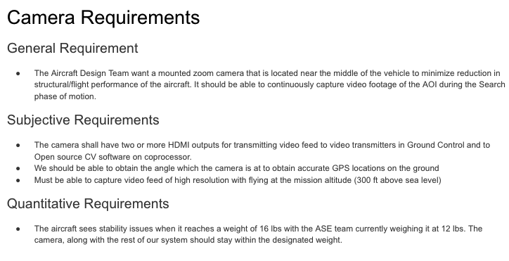

The first Subjective Requirement states “HDMI outputs for transmitting video feed to video transmitters in Ground Control…”. Should this be “HDMI outputs for transmitting video feed via aircraft video transmitter to Ground Control…”?

Second and third subjective requirements: “Should” and “Must” are not preferred for requirements. “Shall” is preferred. Second subjective requirement may mean aircraft coordinates and attitude and/or gimbal angles - need to make that clear.

Quantitative Requirements - Is this actually a stability issue or a performance issue (e.g., a rate of climb issue)? Perhaps you are referring to a CG issue. Need to clairfy.

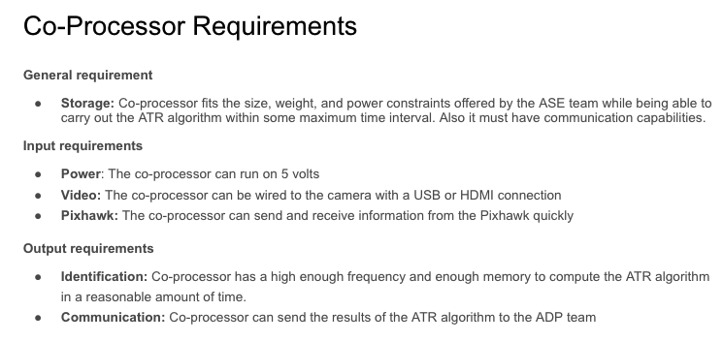

Camera requirement (Subjective Requirement #1) states that the connection shall have an HDMI interface, but the input requirement here states USB or HDMI. Need to make it the same.

Pixhawk send and receive rate is stated as “quickly”. This is a subjective requirement at best. Rate should be specified (can annotate with [TBR], where TBR means “To Be Revised”).

Output requirements - qualitative specifications of frequency and memory requirements. Better to specify an estimate and follow with [TBR],

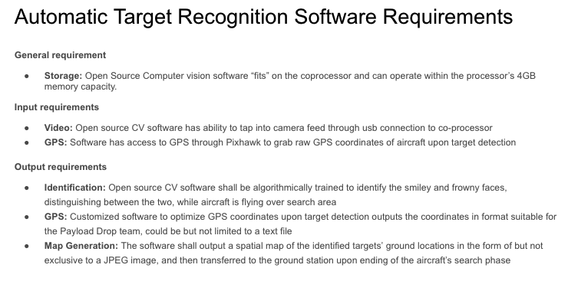

General Requirement - No “shall” found. Are “fits” and “4GB memory capacity” redundant?

Input Requirements - No “shalls” found.

Output Requirements - GPS: No “shall” found.

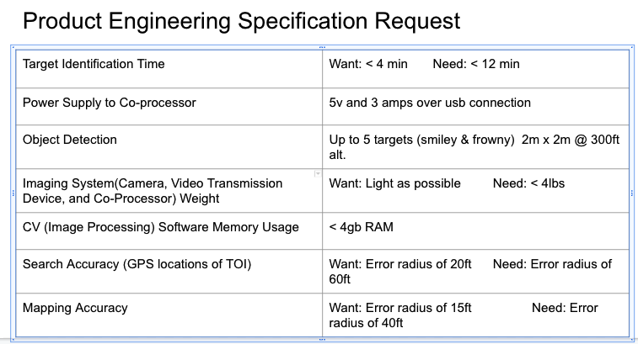

The usual terms used are “Objective” and “Threshold” versus “Want” and “Need”.

The search altitude per Riley’s note is 320 ft per their current ConOps. This may be subject to some adjustment. May want to consider a range of altitudes from xxx to yyy, where yyy is 400 ft max per FAR 107.

Imaging System Weight: “Light as Possible” is not a proper requirement - needs to be specific (can be an estimate followed by TBR) Weight of 4 lbs is way too heavy. Suggest that you coordinate with the ASE team on a weight allocation.